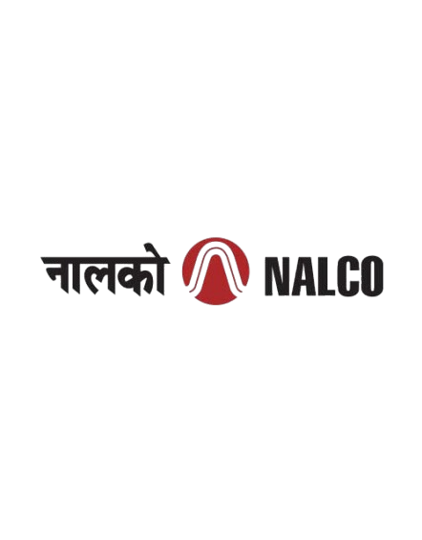
National Aluminium Company Limited
NALCO Bhawan
Nayapalli, Bhubaneswar
A Report On
PROJECT MANAGEMENT SYSTEM
In Web Development
Submitted By
Bikash Ranjan Hota (2301109119)
Department Of Computer Science Engineering

Parala Maharaja Engineering College,
Berhampur , Odisha
Under The Guidance Of
Asir Uddin Ahamed (Asst. General Manager , System)
Asir Uddin Ahamed (Asst. General Manager , System)
National Aluminium Company Limited
NALCO Bhawan
Nayapalli, Bhubaneswar

ABSTRACT
In today's fast-paced digital environment, managing projects efficiently has become essential for organizations, educational institutions, startups, and development teams. As projects become more collaborative and involve multiple stakeholders, maintaining task schedules, tracking progress, and ensuring effective communication often become challenging. Traditional methods of project management, such as spreadsheets and manual documentation, are time-consuming, difficult to maintain, and prone to errors. To address these challenges, this project presents PROJECTBEACON, a web-based Project Tracking and Management System designed to simplify project planning, task management, and team collaboration through a centralized digital platform.
The system has been developed as a full-stack web application that enables project managers and team members to work together in an organized and transparent manner. The application supports role-based access, allowing authorized users to create and manage projects, assign tasks to team members, monitor task progress, and track the overall status of ongoing projects. Team members can access their assigned tasks, update their progress, and collaborate within their respective projects, while administrators are provided with the necessary controls to oversee project activities and manage users. A responsive and user-friendly interface has been implemented to ensure smooth accessibility across desktops, tablets, and mobile devices, making project monitoring convenient from any location.
The application has been built using modern web technologies to provide reliability, scalability, and high performance. The frontend has been developed using React.js, along with HTML (HyperText Markup Language), CSS (Cascading Style Sheets), and JavaScript, creating an interactive and responsive user interface. The backend has been implemented using Node.js and Express.js, which provide efficient server-side processing and API management. MongoDB has been used as the database to store project information, user details, and task records securely and efficiently. The application has been deployed on Vercel, enabling easy access, smooth performance, and simplified maintenance.
The Project Tracking and Management System has been developed to improve project organization, enhance collaboration among team members, and provide real-time visibility into project progress. By integrating project planning, task allocation, and progress monitoring into a single platform, the system offers a practical, scalable, and efficient solution for managing projects of varying sizes while promoting accountability, productivity, and timely project completion.
Keywords: Project Tracking System, Project Management, Task Management, Team Collaboration, React.js, Node.js, MongoDB, Web Application, Role-Based Access, Full-Stack Development.

Name: Bikash Ranjan Hota
Registration No.: 2301109119 Signature of the Student

ACKNOWLEDGEMENT

I would like to express my sincere gratitude to my project guide, Mr. Asir Uddin Ahamed, Department of Systems, for his constant guidance, valuable suggestions, and continuous encouragement throughout the development of this project. His technical expertise, constructive feedback, and patient mentoring have been instrumental in helping me successfully complete this work. His support at every stage of the project greatly enhanced my understanding of full-stack web development and project management concepts.
I would also like to extend my heartfelt thanks to Mr. Bharat Mohan Dang (DM, HR) for recommending me and providing the opportunity and motivation to undertake this project. His encouragement and support have been invaluable in my learning journey and professional development.
I would like to acknowledge the trust and opportunity provided by NALCO, which enabled us to undertake this project. It has been an enriching experience working with them, and I am truly grateful for the knowledge and skills I have acquired during this journey.
Special thanks to my college- Parala Maharaja Engineering College for providing me with the opportunity and support to pursue this internship, which has helped me gain valuable knowledge and practical experience and also thanks to my peers and fellow interns for their collaborative spirit and helpful discussions, which made this internship an enriching and enjoyable experience. Lastly, I express my sincere appreciation to everyone who, directly or indirectly, contributed to the successful completion of this project. This internship has been a great learning experience and has significantly strengthened my knowledge in Web Development.

Signature of the Student

CONTENTS
Topic Name Page No.

- Introduction 1
- Problem Statement 2
- Objectives 3
- Features and Functionalities 4
- System Design 5-7
- Modules of the Project 8-9
- Technologies Used 10-15
- Software Testing and Validation 16
- Challenges Faced 17
- Limitations 18
- Future Scope 19
- Conclusion 20
- References 21

LIST OF FIGURES

Figures Page no.
ER DIAGRAM OF WEBSITE 5
CLIENT SERVER MODEL DIAGRAM 6
DATA FLOW DIAGRAM 7
USER MODULE 8
FOOD MODULE 9
ORDER MODULE 9
HOME PAGE 10
MENU PAGE 11
CART PAGE 12
PLACE ORDER PAGE 12
LOGIN PAGE 12
MONGO DB 14
DEPLOYMENT IN RENDER 15
STRIPE PAYMENT 15
ADMIN PANEL 1

INTRODUCTION

In the modern digital era, organizations, educational institutions, startups, and software development teams are increasingly managing multiple projects simultaneously. As projects become more complex and involve multiple team members, maintaining coordination, tracking task progress, and meeting deadlines become significant challenges. Traditional methods such as spreadsheets, paper-based records, and scattered communication often lead to inefficient task management, lack of transparency, and reduced productivity. These limitations create the need for a centralized platform that simplifies project management while improving collaboration.
To address these challenges, Projectbeacon – Project Tracking and Management System has been developed as a full-stack web application that provides an efficient and user-friendly platform for planning, organizing, and monitoring projects. The system enables users to create projects, assign tasks, monitor progress, and manage project activities through a centralized dashboard. By bringing all project-related information into a single platform, it improves communication, enhances accountability, and helps ensure the timely completion of projects.
The application has been designed by considering the needs of different users involved in project execution. Administrators and project managers can create and manage projects, assign tasks, and monitor overall project progress, while team members can access their assigned tasks, update their work status, and collaborate effectively. The implementation of role-based access control ensures secure access to project information and maintains data integrity.
The project demonstrates the practical implementation of modern full-stack web development technologies. The frontend has been developed using React.js, HTML (HyperText Markup Language), CSS (Cascading Style Sheets), and JavaScript, while the backend is built using Node.js and Express.js. MongoDB has been used for efficient data management, and the application has been deployed on Vercel for easy accessibility and reliable performance.
This report presents the objectives, system design, implementation, key features, and technologies used in developing ProjTrack. It also discusses the challenges faced during development and highlights how the system provides a practical, scalable, and user-friendly solution for effective project management and team collaboration.
By combining modern software engineering principles with practical project management requirements, ProjTrack provides a dependable and efficient solution for managing projects of varying sizes. The system not only improves task organization and team collaboration but also demonstrates the effective use of contemporary web technologies in developing a real-world application that supports productivity, transparency, and successful project execution.
PROBLEM STATEMENT

In today's fast-paced digital environment, organizations, educational institutions, and software development teams often manage multiple projects involving several team members working simultaneously. Coordinating project activities, assigning tasks, monitoring progress, and meeting deadlines become increasingly challenging when relying on traditional methods such as spreadsheets, paper-based records, or scattered communication through emails and messaging platforms. These approaches often lead to poor coordination, lack of transparency, missed deadlines, and difficulty in tracking project performance.
Project managers frequently face challenges in assigning responsibilities, monitoring task completion, and obtaining a clear overview of ongoing projects. Similarly, team members may find it difficult to track their assigned tasks, update progress, and collaborate effectively with other members. The absence of a centralized platform often results in miscommunication, duplication of work, and delays in project execution, ultimately affecting overall productivity.
Furthermore, many existing project management solutions are either too complex, expensive, or include features that are unnecessary for small organizations, startups, and academic project teams. Some systems also lack intuitive user interfaces, flexible role-based access, and efficient project monitoring capabilities, making them less suitable for users seeking a simple yet effective project management solution.
These challenges highlight the need for a secure, user-friendly, and scalable Project Tracking and Management System that provides a centralized platform for project planning, task assignment, progress monitoring, and team collaboration. Such a system can improve communication, enhance accountability, streamline project workflows, and enable organizations to manage projects more efficiently while ensuring timely completion of tasks.

OBJECTIVES

The objectives of the Project Tracking and Management System (ProjTrack) are focused on improving project organization, enhancing team collaboration, and providing an efficient platform for monitoring project progress. The key objectives are as follows:
1. Centralized Project Management
The system provides a centralized platform where users can create, organize, and manage multiple projects efficiently. This helps maintain all project-related information in one place, reducing confusion and improving accessibility.
2. Efficient Task Assignment and Tracking
The application enables project managers to assign tasks to team members, define responsibilities, and monitor task progress. This ensures better accountability and helps projects stay on schedule.
3. Improved Team Collaboration
The system facilitates effective collaboration by allowing team members to access their assigned tasks, update work progress, and remain informed about project activities. This minimizes communication gaps and enhances overall productivity.
4. Secure Role-Based Access
The application implements role-based authentication to ensure that users can access only the features and information relevant to their responsibilities. This enhances data security and maintains the integrity of project information.
5. User-Friendly and Responsive Design
The platform is designed with a simple, intuitive, and responsive interface that provides a seamless user experience across desktops, tablets, and mobile devices, making project management convenient from anywhere.
6. Scalability and Future Enhancement
The system is developed using modern web technologies that support scalability and easy maintenance. Its architecture allows future enhancements, such as real-time notifications, file sharing, analytics, and integration with third-party collaboration tools, without affecting existing functionality.

FEATURES AND FUNCTIONALITIES

The Project Tracking and Management System (ProjTrack) incorporates a comprehensive set of features designed to simplify project planning, improve task management, and enhance collaboration among team members. The system provides a centralized environment where project managers and team members can efficiently organize, monitor, and complete projects. The major features and functionalities are described below:
User Registration & Authentication:
The system provides a secure authentication mechanism that allows users to register and log in using their credentials. Authentication ensures that only authorized users can access the platform, protecting project information and maintaining system security.
Role-Based Access Control:
The application supports different user roles, such as administrators, project managers, and team members. Each role is assigned specific permissions and responsibilities, ensuring that users can only access features relevant to their assigned role while maintaining data integrity and security.
Project Creation & Management:
Authorized users can create new projects by providing project details such as the project name, description, deadlines, and other relevant information. Existing projects can also be updated, managed, or removed whenever required, allowing efficient organization of multiple projects.
Task Assignment & Management:
Project managers can create tasks, assign them to individual team members, define priorities, and specify deadlines. Team members can view their assigned tasks and update their progress as work is completed, ensuring accountability and better coordination among the team.
Project Progress Tracking:
The platform enables users to monitor the status of projects and tasks in real time. Progress updates help managers identify pending, ongoing, and completed tasks, allowing them to evaluate project performance and take corrective actions whenever necessary.
Dashboard & Project Overview:
The system provides an interactive dashboard that offers a consolidated view of project activities. Users can quickly access project summaries, task statistics, progress indicators, and other important information, making project monitoring simple and efficient.

Team Collaboration:
The platform encourages collaboration by allowing team members to work within the same project environment. Shared access to project information improves communication, reduces misunderstandings, and ensures that every team member remains informed about project activities.
Responsive User Interface:
The application features a clean, intuitive, and responsive interface that delivers a consistent user experience across desktops, laptops, tablets, and mobile devices. This enables users to access and manage projects conveniently from different locations.
Database Management:
All project information, user accounts, task details, and progress records are securely stored using MongoDB. The database structure ensures efficient data retrieval, reliable storage, and easy maintenance of project information.
Deployment & Scalability:
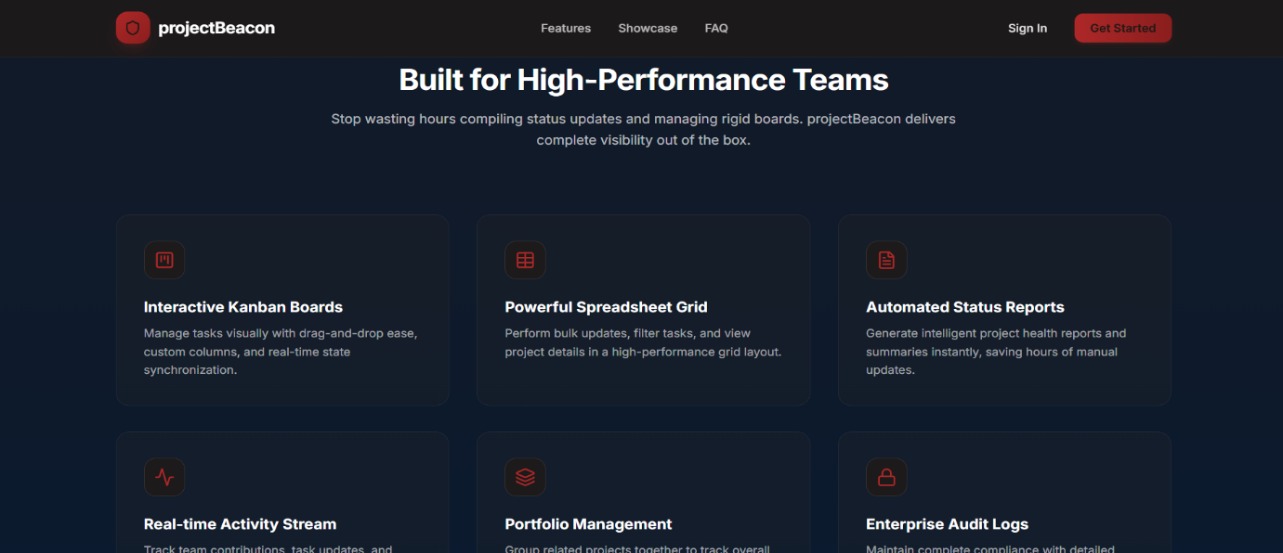

The application has been deployed on Vercel, making it easily accessible through modern web browsers. The system architecture is designed to support future enhancements, allowing new features and increased user capacity without affecting overall performance.
FIG 1 : FEATURES OF PROJECTBEACON – PROJECT TRACKING AND MANAGEMENT SYSTEM
SYSTEM DESIGN

Entity-Relationship (ER) Diagram
The Entity-Relationship (ER) Diagram represents the logical structure of the database used in the Project Tracking and Management System. It illustrates the main entities, such as Users, Projects, Tasks, Project Members, and Task Progress, along with their attributes and relationships. For example, a user can create and manage multiple projects, each project can contain multiple tasks, and every task can be assigned to a team member and updated as work progresses. By organizing the data in this manner, the ER diagram provides a clear understanding of how information is stored, connected, and managed within the system, ensuring efficient data organization and smooth project management operations.
The ER diagram serves as the foundation for the database design by defining the structure of data and the associations between different entities. It helps maintain data consistency, minimizes redundancy, and supports efficient storage and retrieval of project information, ultimately contributing to the smooth operation of the Project Tracking and Management System.
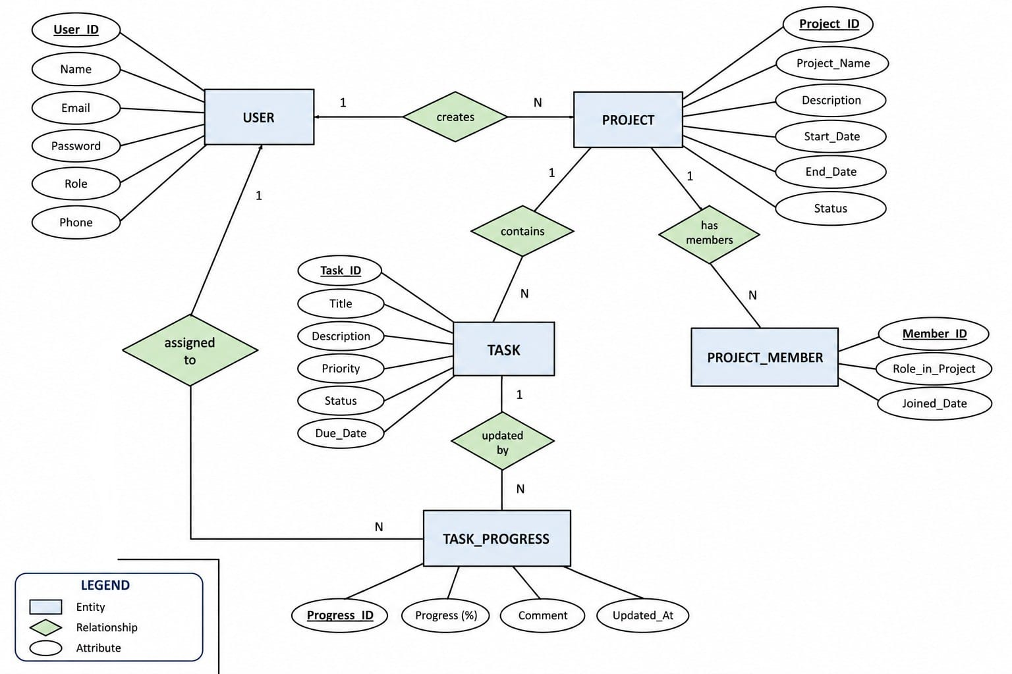

Fig 2 : ER Diagram of the PROJECTBEACON
Client-Server Model
The Project Tracking and Management System follows a client-server architecture, where the client is the user's web browser and the server-side services are provided through Supabase (Backend as a Service). The client, developed using Next.js and Tailwind CSS, sends requests such as user authentication, project creation, task updates, and data retrieval. Supabase processes these requests, manages authentication, interacts with the PostgreSQL database, and returns the required information to the client. This architecture ensures secure communication, efficient data management, and a responsive user experience while supporting scalability and reliable system performance.

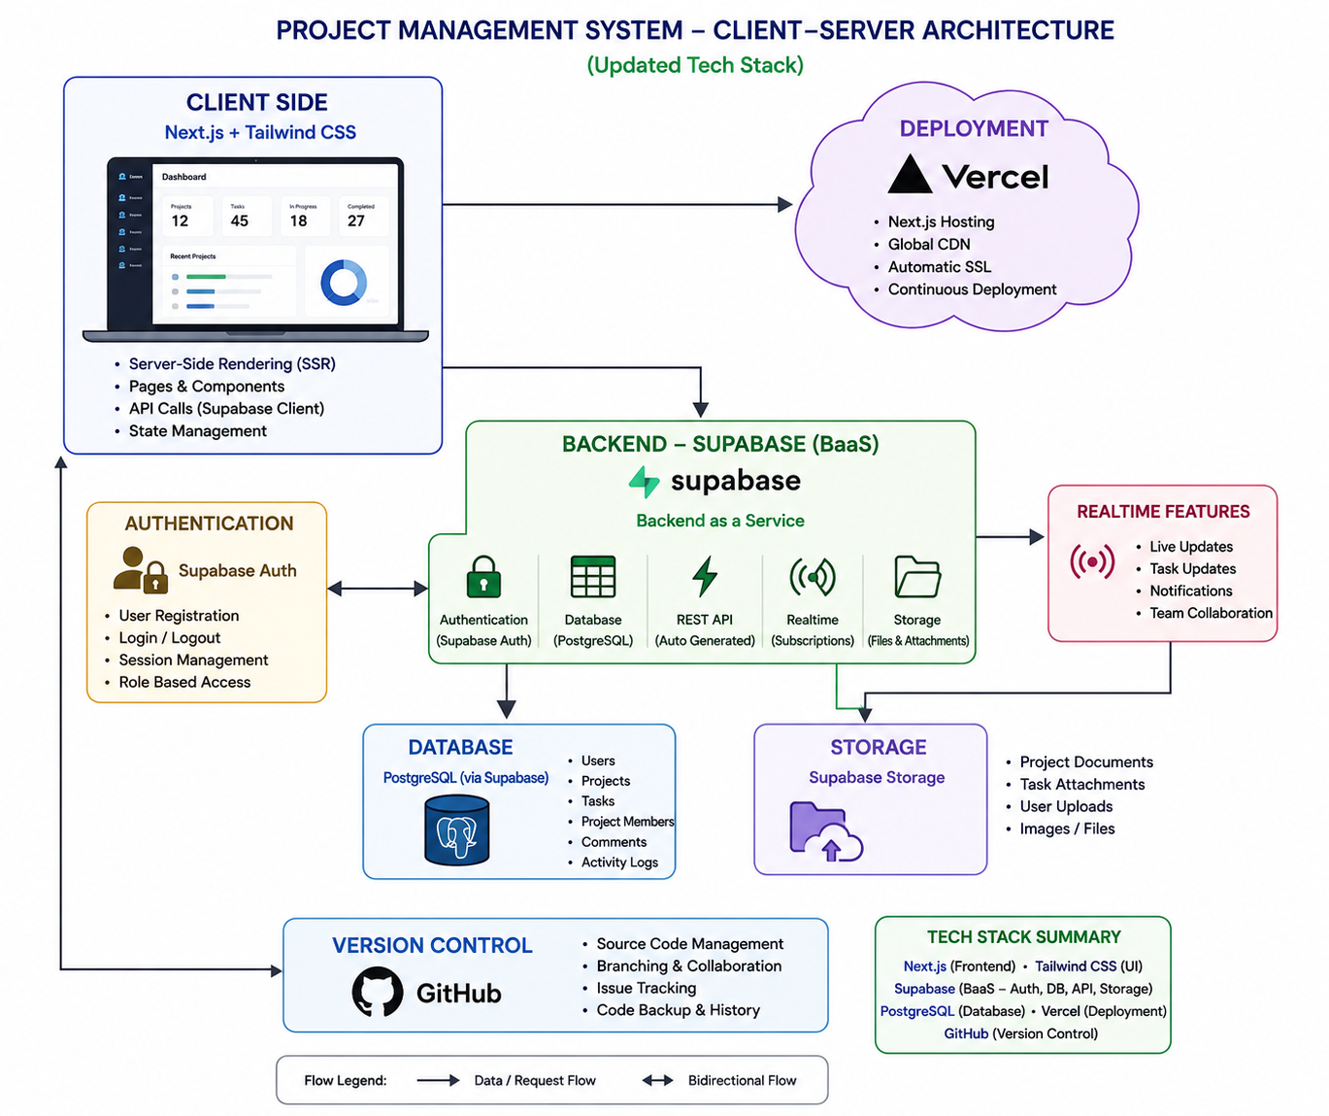
FIG 3: CLIENT SERVER MODEL DIAGRAM

Data Flow Diagram (DFD)
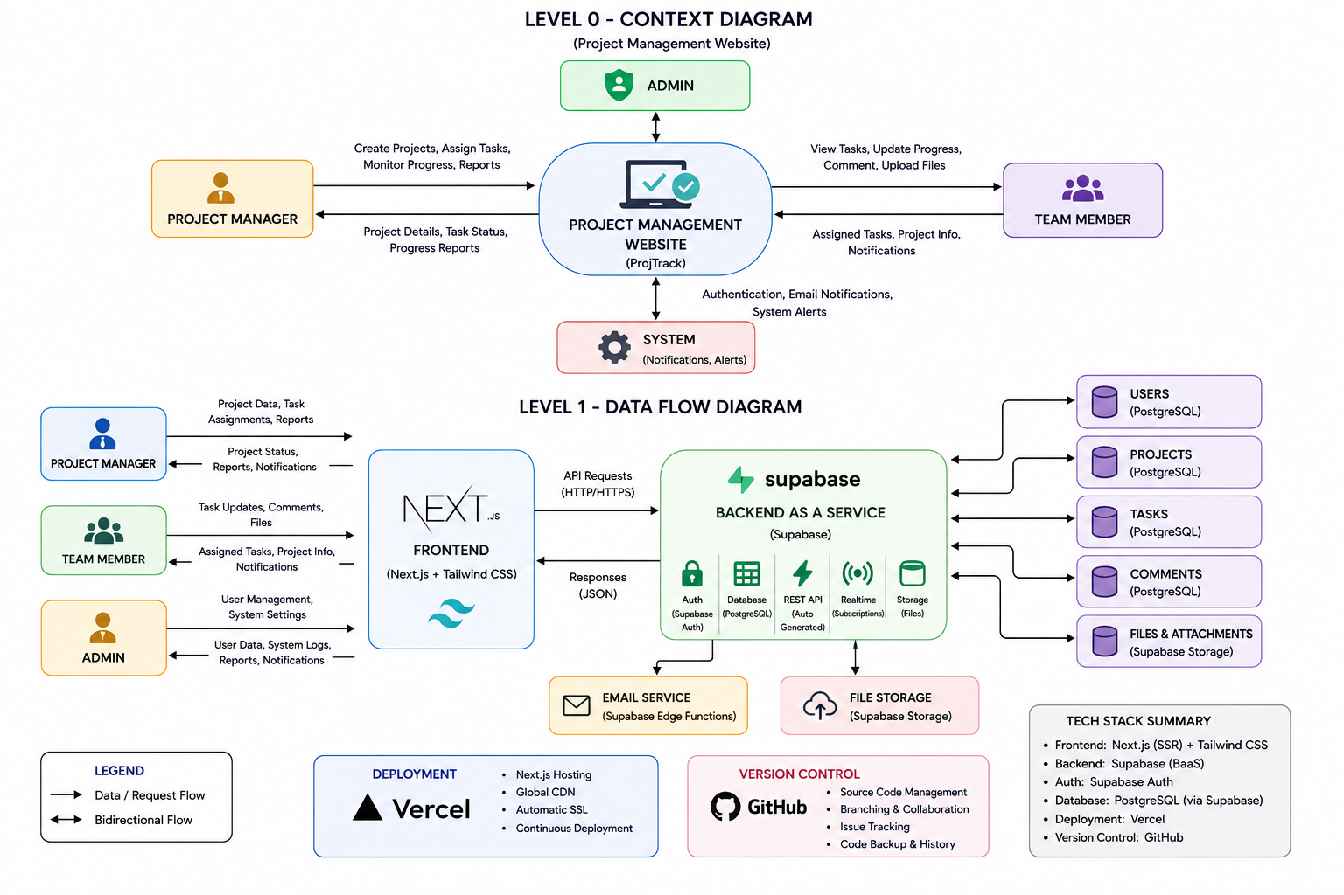

The Data Flow Diagram (DFD) illustrates how information moves through the Project Tracking and Management System and how different users interact with the application. Users such as administrators, project managers, and team members perform activities like logging in, creating projects, assigning tasks, updating progress, and viewing project details. The data flows between the frontend, Supabase backend services, and the PostgreSQL database, where it is processed and stored securely. The DFD provides a clear understanding of how data is exchanged between users, the system, and the database to ensure efficient project management and collaboration.

FIG 4: DATA FLOW DIAGRAM
MODULES OF THE PROJECT
User Module
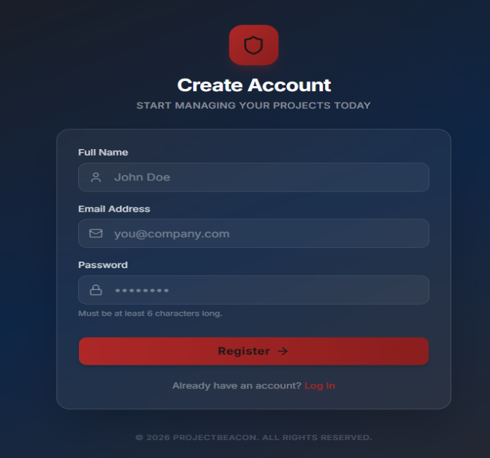
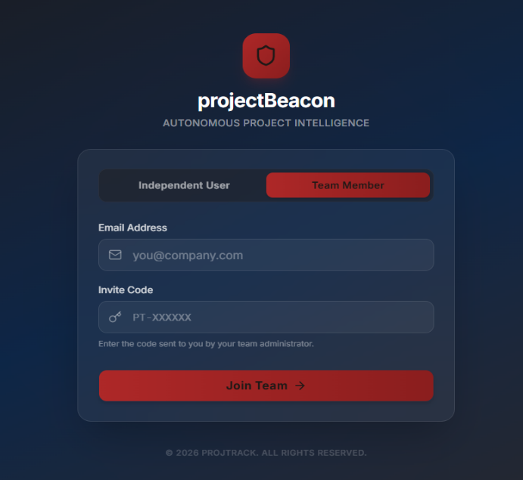
The User Module manages all operations related to user accounts, including registration, login, authentication, and profile management. The system uses Supabase Authentication to provide secure access and session management for all users. User information such as name, email, and assigned role is stored securely in the PostgreSQL database. Role-based access control ensures that administrators and team members can access only the features relevant to their responsibilities, enhancing both security and system reliability.
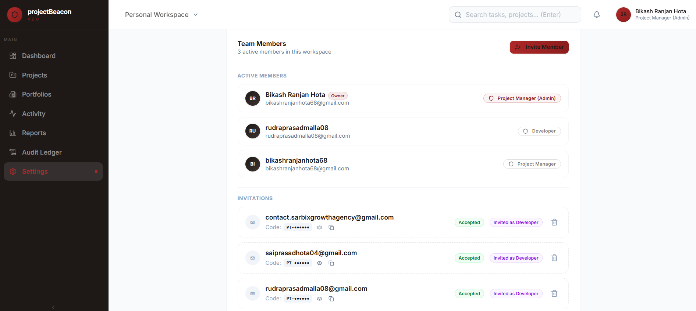

FIG 5: USER MODULE
Project Module
The Project Module is the core component of the system and is responsible for creating, organizing, and managing projects. Users can create new projects, update project details, monitor project progress, and view project status through an interactive dashboard. Each project contains information such as project name, description, priority, deadlines, and completion status. The module enables efficient organization of multiple projects and provides a centralized platform for monitoring project activities.
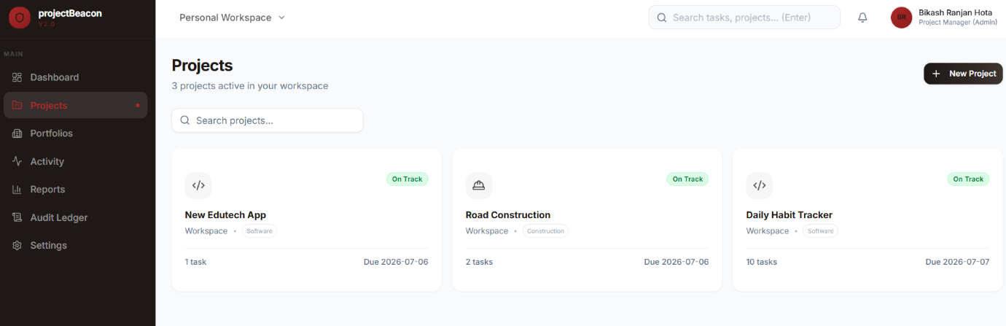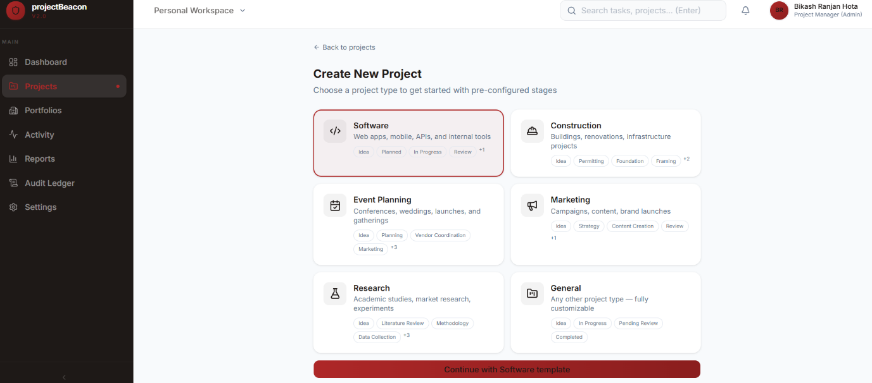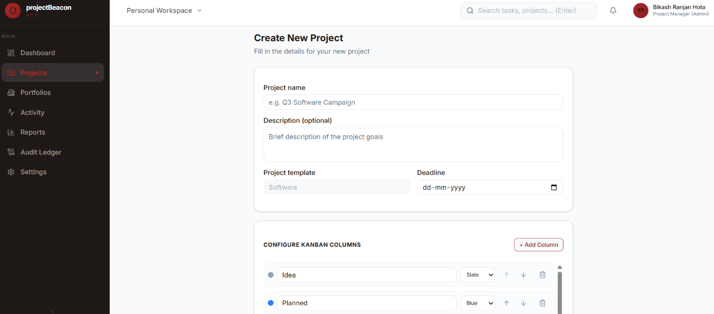
FIG 6: PROJECT MODULE
Task & Activity Module
The Task & Activity Module manages task creation, assignment, and progress tracking throughout the project lifecycle. Project managers can assign tasks to team members, set priorities and deadlines, while team members can update the status of their assigned work. The system also maintains an activity log that records important events such as project creation, task updates, and status changes. This module improves team collaboration, increases accountability, and provides better visibility into ongoing project activities.
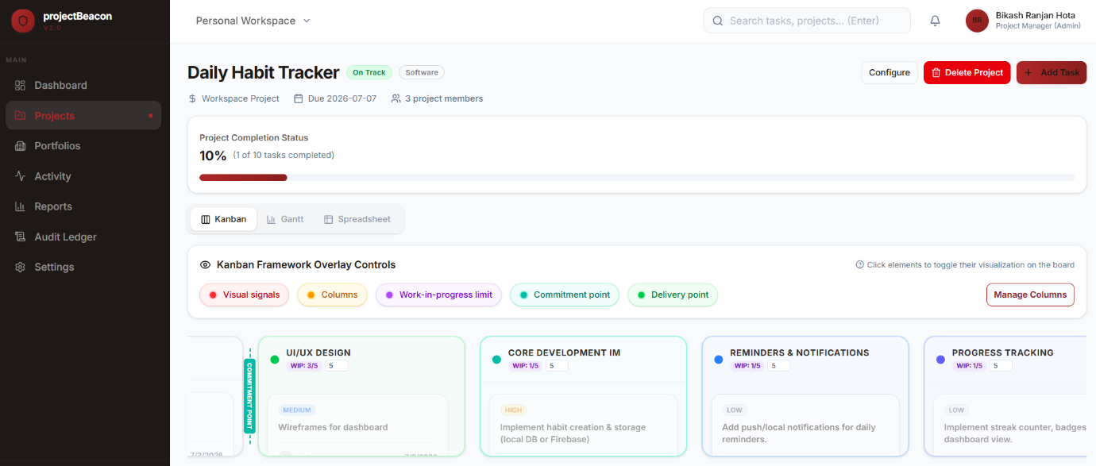
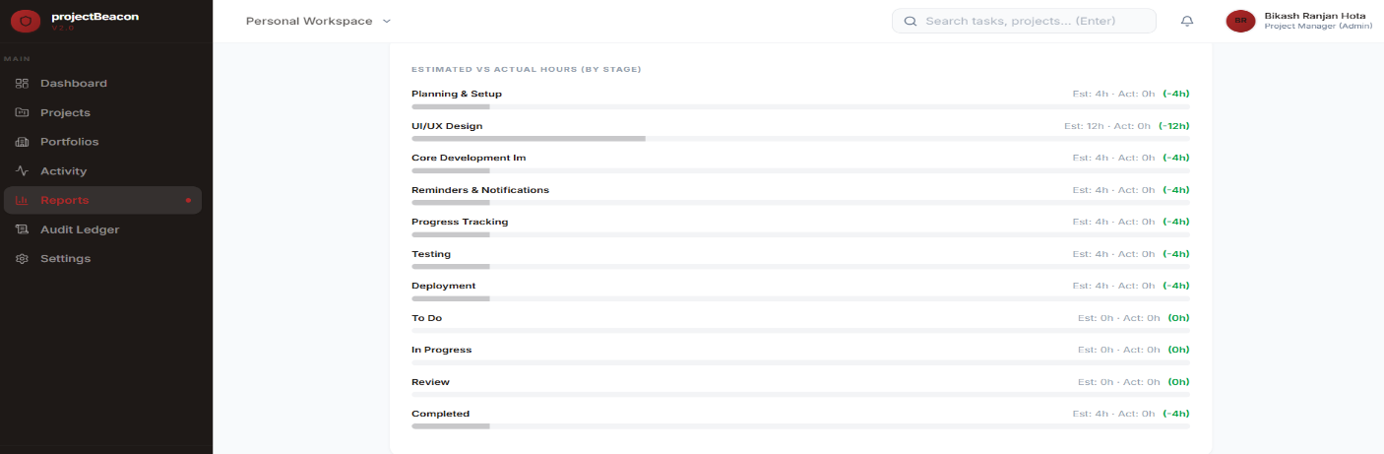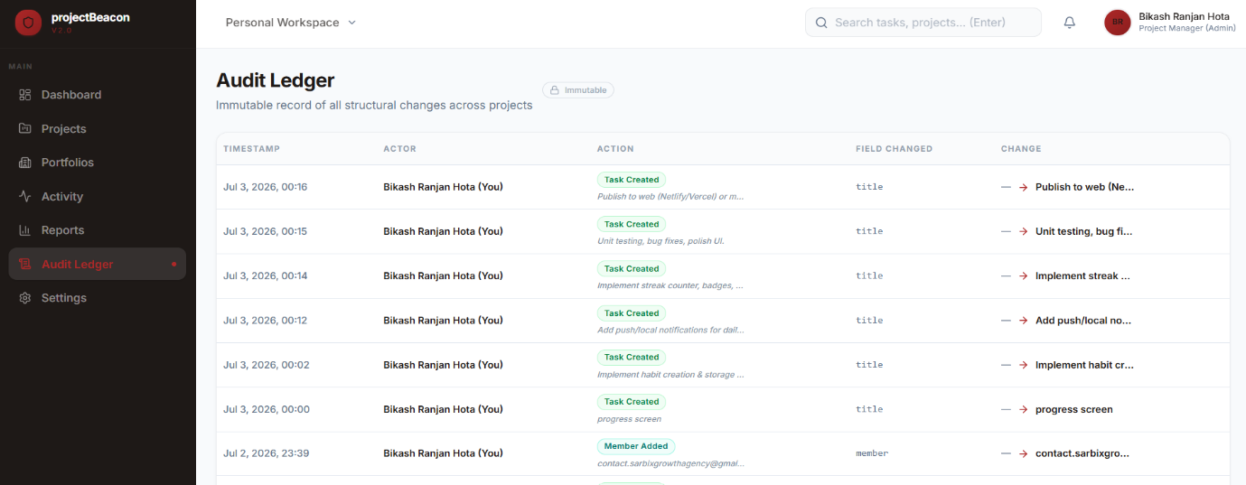
FIG 7: TASK & ACTIVITY MODULE

Reports & Settings Module
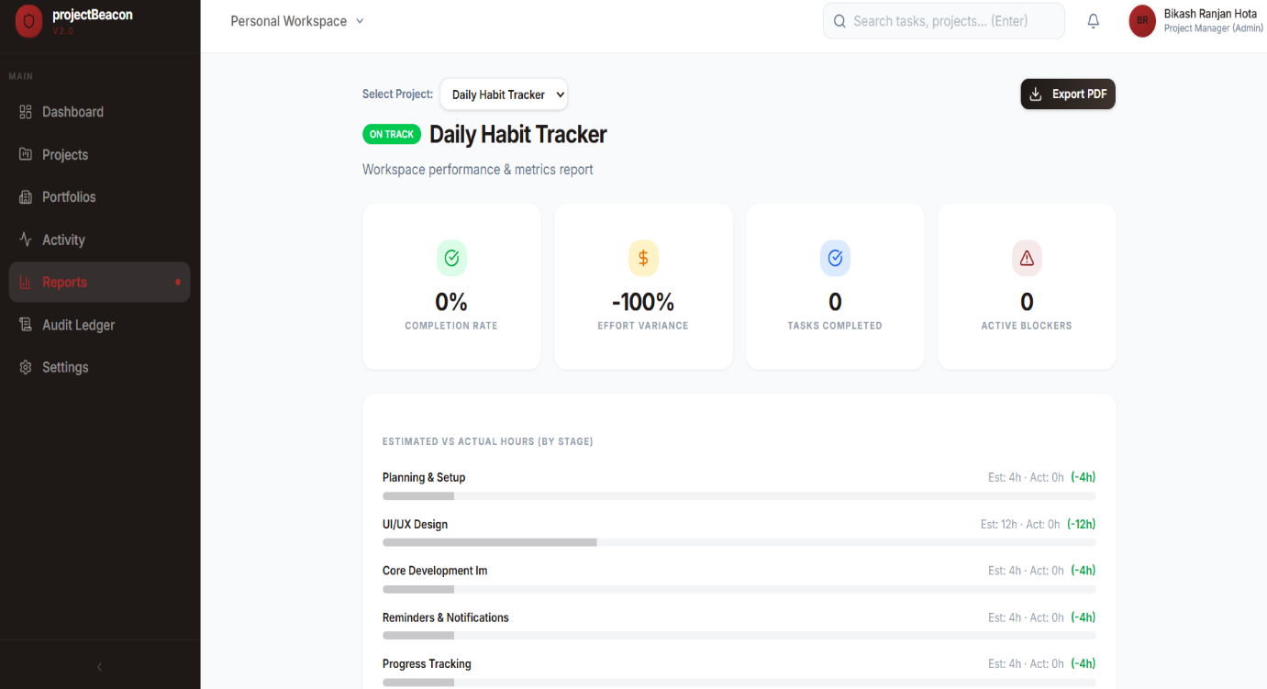
The Reports & Settings Module provides project summaries, progress reports, and administrative controls for managing the workspace. Users can monitor project performance through reports and dashboard statistics, helping them evaluate the current status of projects and identify pending work. The settings section allows administrators to manage workspace preferences, team members, and system configurations, ensuring smooth operation and efficient management of the Project Tracking and Management System.
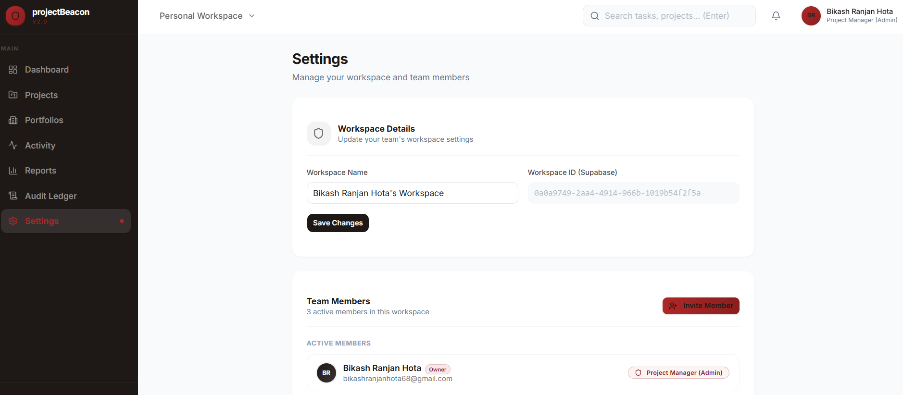

FIG 8: REPORTS & SETTINGS MODULE
TECHNOLOGIES USED
The Project Tracking and Management System has been developed using modern web technologies to provide a secure, scalable, and responsive web application. Each technology was selected based on its capabilities and applied to different parts of the system to ensure efficient project management and seamless user experience.
Next.js (Frontend Framework with Server-Side Rendering)
Next.js was used as the primary frontend framework for developing the web application. It provides Server-Side Rendering (SSR), file-based routing, and optimized performance, enabling faster page loading and improved user experience.
Applications in this project:
- Developed the landing page, dashboard, project pages, reports, and settings.
- Implemented file-based routing for smooth navigation between different modules.
- Used reusable components to build a clean and maintainable user interface.
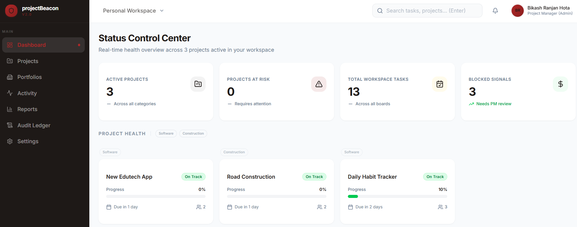

- Improved application performance through server-side rendering and optimized page loading.
FIG 9: LANDING PAGE & DAHBOARD
Tailwind CSS
Tailwind CSS was used to design the user interface and create a responsive layout across different devices. Its utility-first approach simplified styling and enabled rapid development of modern web pages.
Applications in this project:
- Designed responsive dashboards, project cards, navigation menus, and forms.
- Created a clean and consistent user interface.
- Applied flexible layouts using Grid and Flexbox.
- Ensured compatibility across desktop, tablet, and mobile devices.
Supabase (Backend as a Service)
Supabase serves as the backend of the application by providing database services, authentication, and APIs without requiring a traditional backend server. It simplifies backend development while ensuring security and scalability.
Applications in this project:
- Managed backend operations and database connectivity.
- Handled CRUD (Create, Read, Update, Delete) operations for projects and tasks.
- Provided secure APIs for communication between the frontend and database.
- Managed user authentication and real-time data updates.
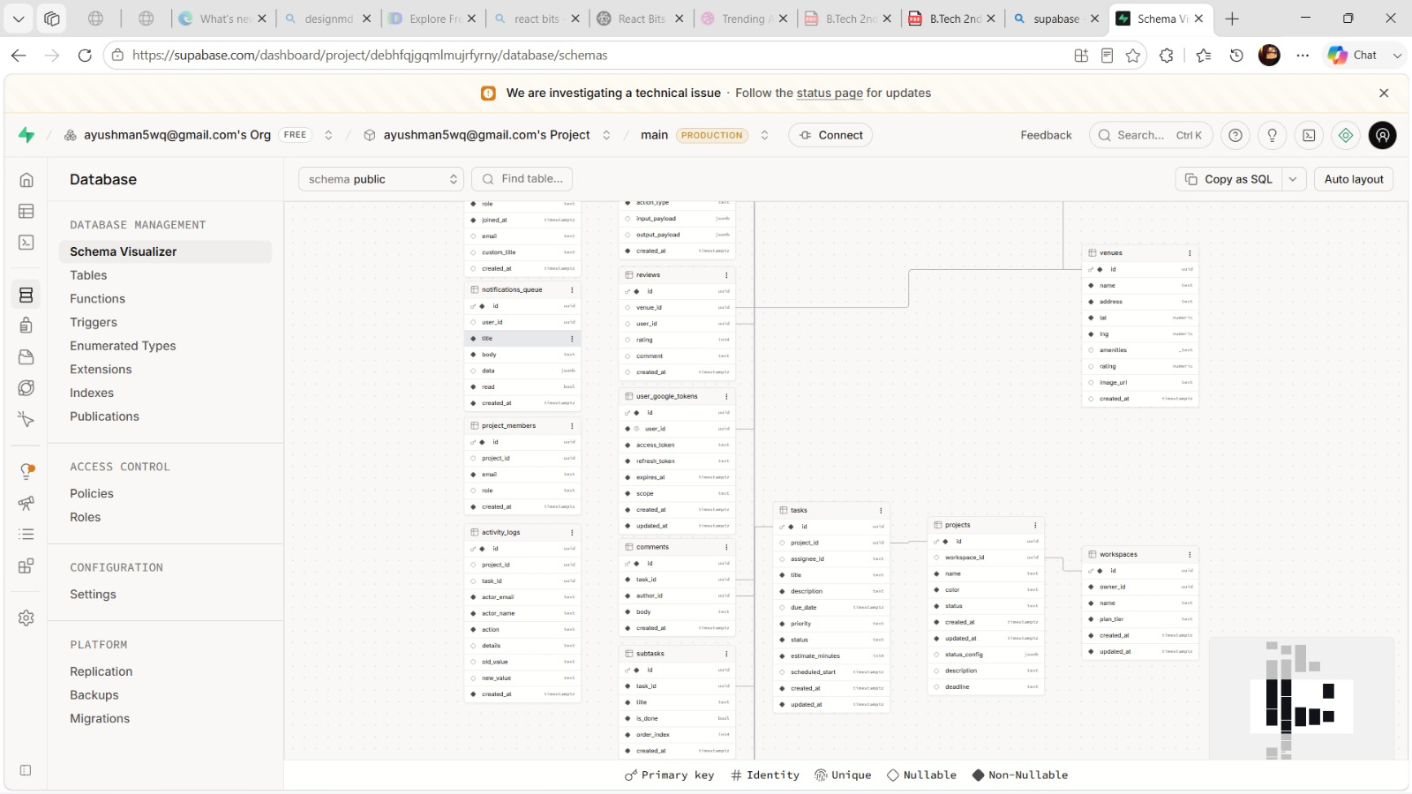
FIG 10: LANDING PAGE & DAHBOARD

PostgreSQL
PostgreSQL is the relational database used to store all application data. It maintains structured information related to users, projects, tasks, activity logs, and workspace settings while ensuring data consistency and reliability.
Applications in this project:
- Stored user profiles and authentication details.
- Managed project and task information.
- Recorded activity logs and project updates.
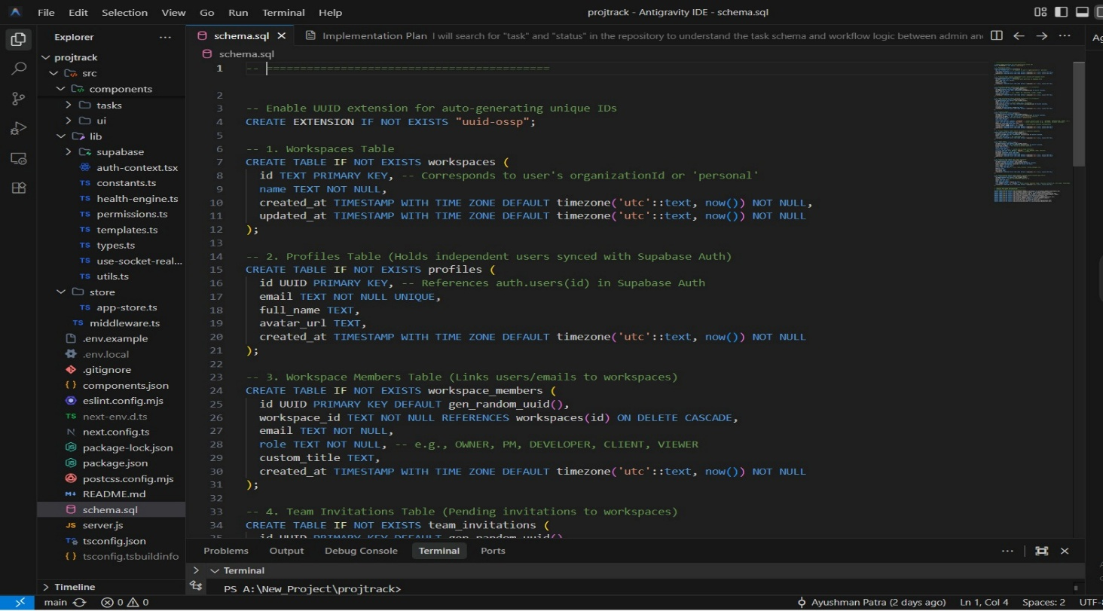
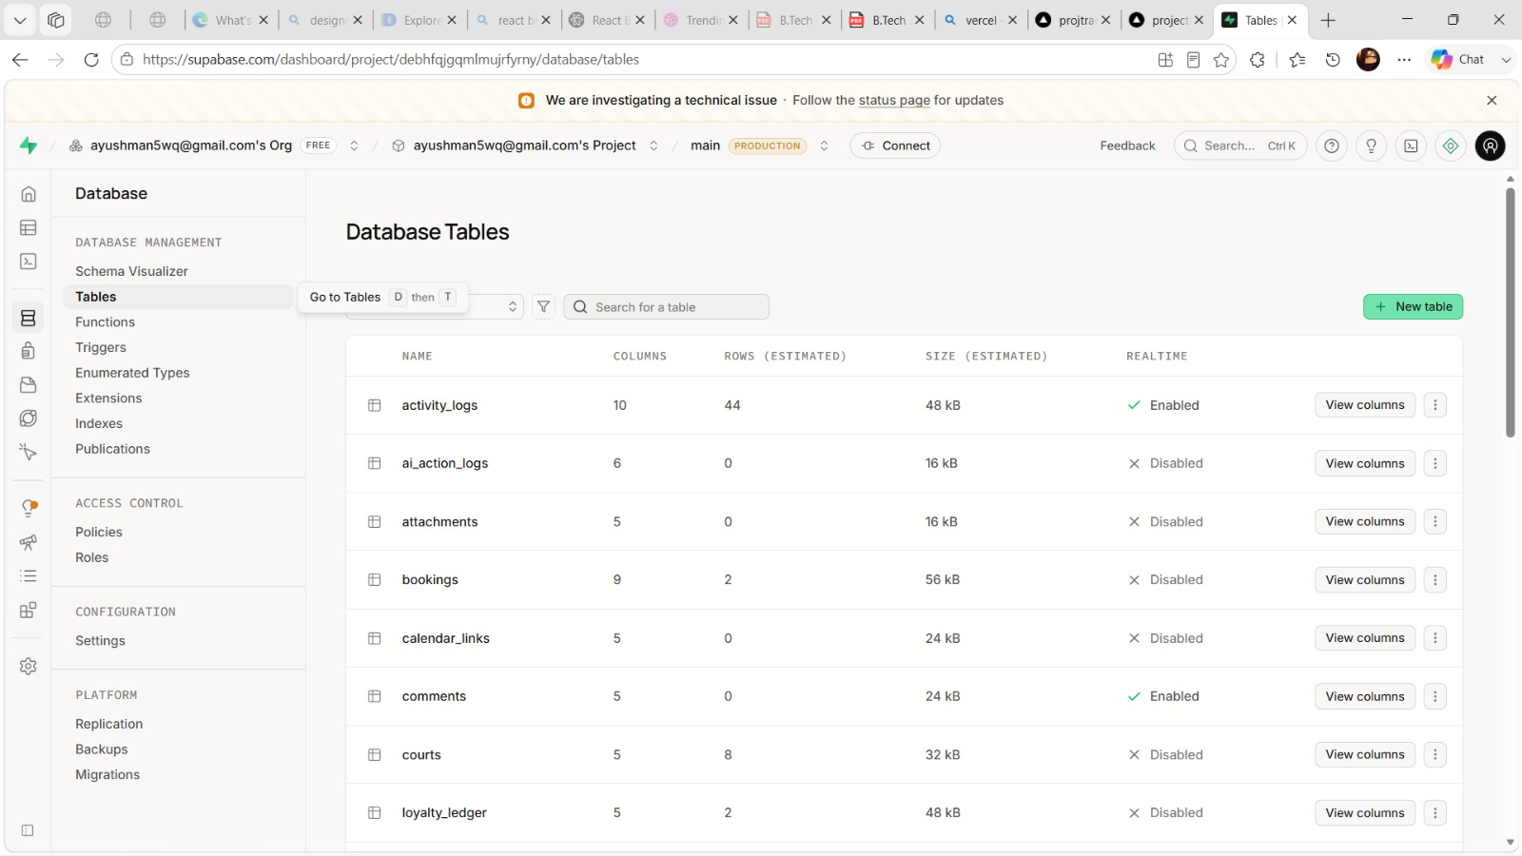
- Supported efficient querying and secure data management.
FIG 11: DATABASE SCHEMA
Supabase Authentication
Supabase Authentication was implemented to provide secure user registration, login, and session management. It simplifies authentication while ensuring that only authorized users can access the application.
Applications in this project:
- User registration and login.
- Secure session management.
- Role-based access control.
- Protected access to project resources.
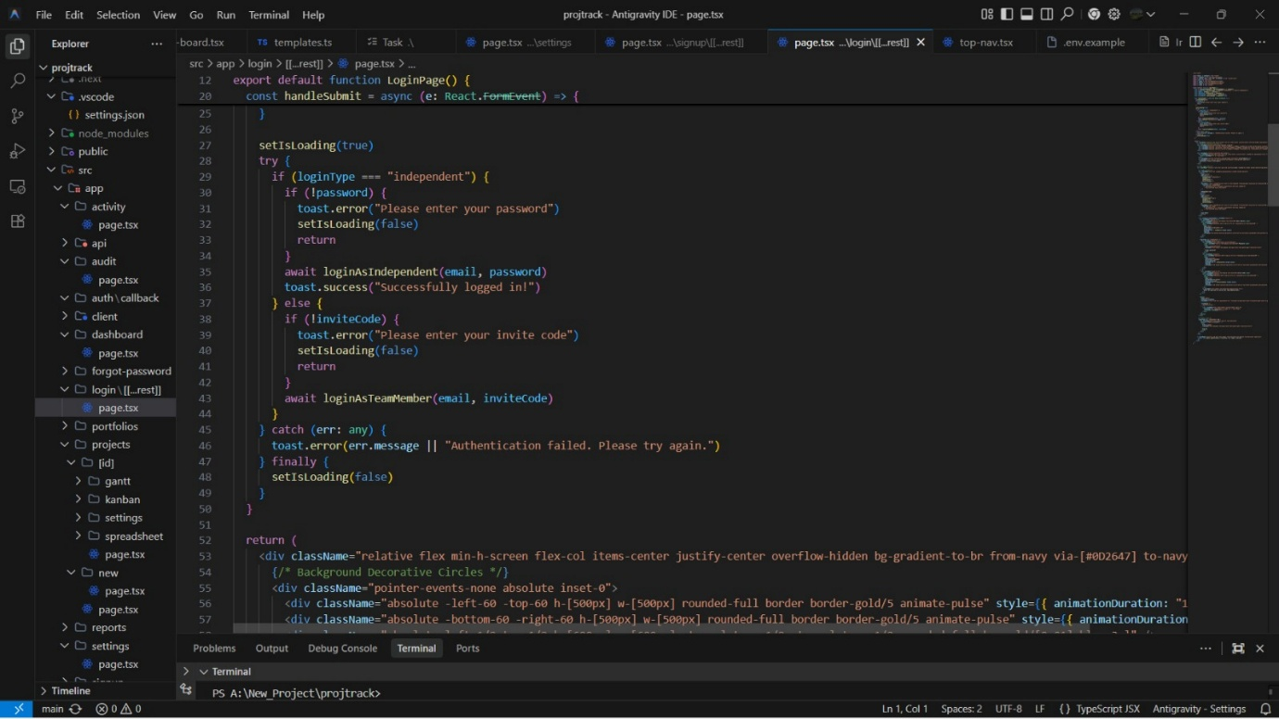
FIG 12: AUTHENTICATION
GitHub
GitHub was used as the version control platform throughout the development of the project. It enabled efficient management of source code, tracked changes, and supported collaboration during development.
Applications in this project:
- Maintained the complete project source code.
- Tracked code modifications using Git.
- Managed different versions of the application.
- Facilitated future maintenance and updates.
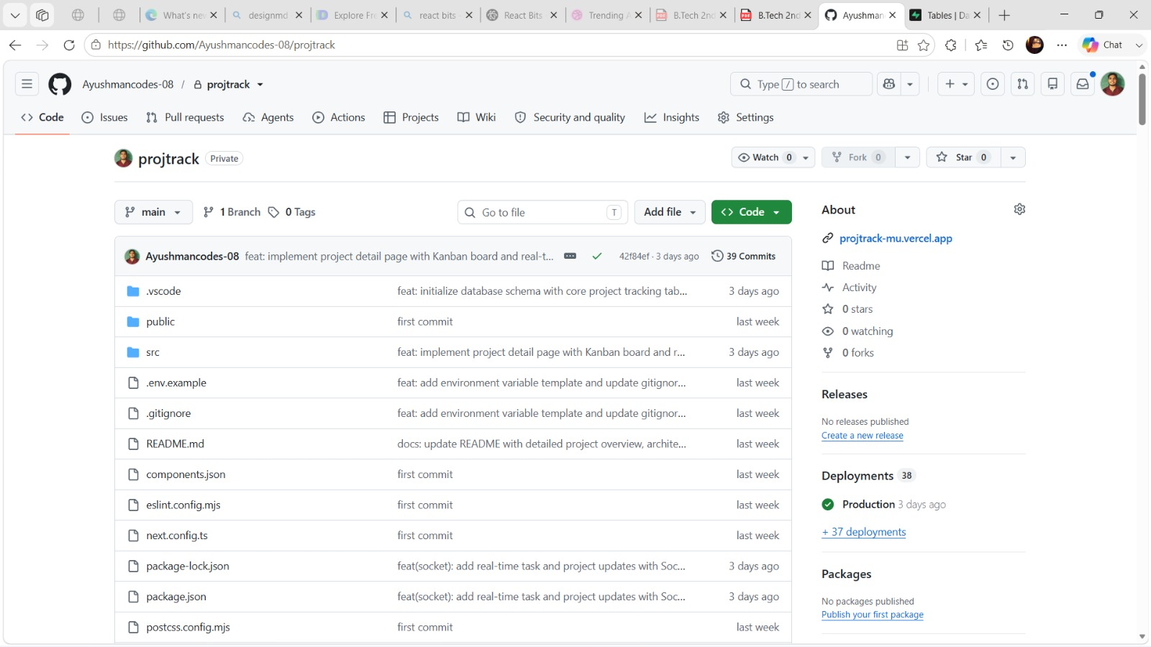
FIG 12: GITHUB VERSION CONTROLL
Vercel
Vercel was used to deploy and host the Project Tracking and Management System. It provides automatic deployment from GitHub and ensures fast, secure, and reliable hosting for Next.js applications.
Applications in this project:
- Hosted the live web application.
- Enabled automatic deployment from GitHub.
- Provided secure HTTPS access.
- Delivered fast page loading through global content delivery.
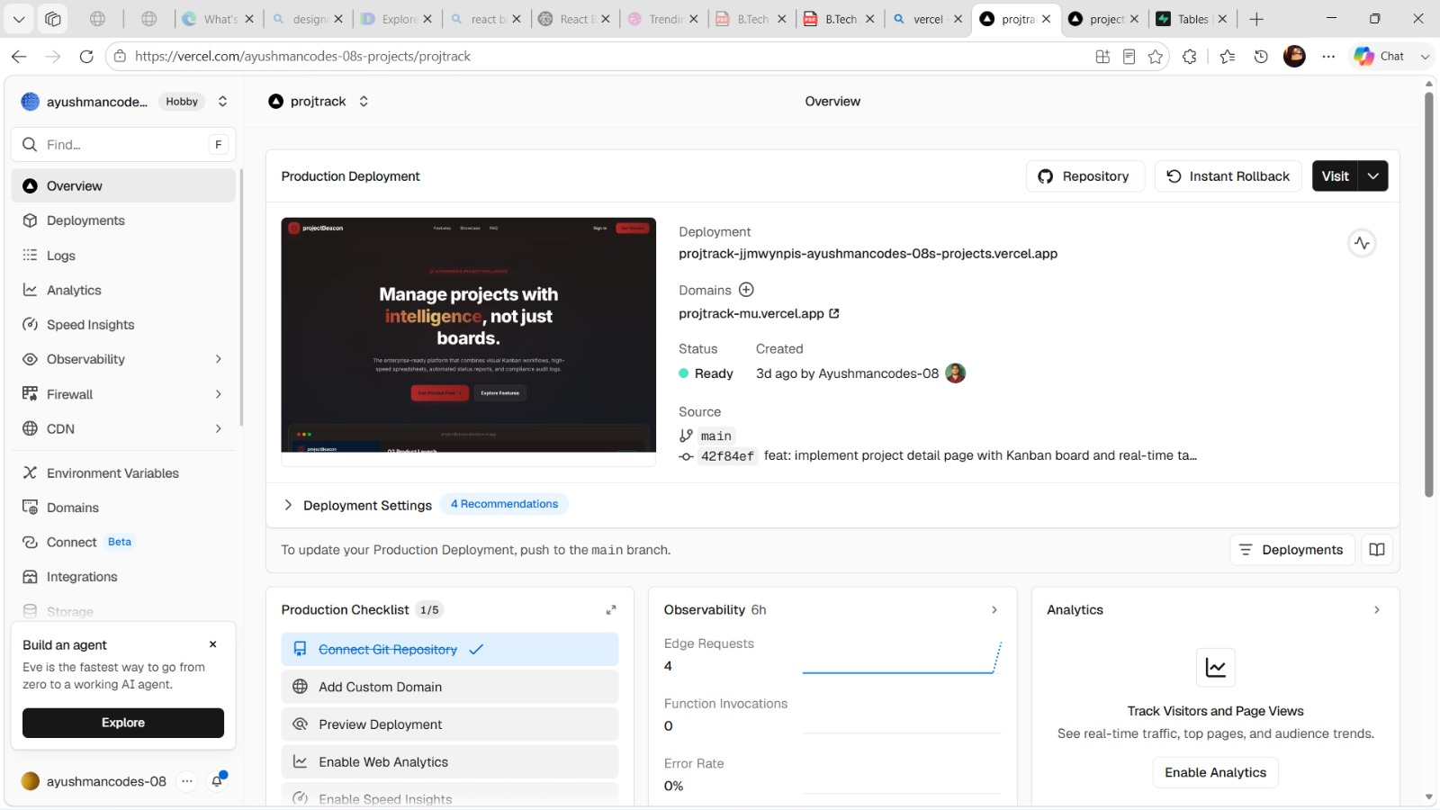
FIG 13: DEPLOY USING VERCEL
SOFTWARE TESTING AND VALIDATION
To ensure the reliability, functionality, and security of the Project Tracking and Management System, different testing techniques were performed during the development process.
1. Unit Testing:
Individual components and modules were tested independently to verify their functionality. Examples include testing user authentication, project creation, task management, and dashboard components to ensure they worked as expected.
2. Integration Testing:
Integration testing was carried out to verify the interaction between the frontend, Supabase backend services, and the PostgreSQL database. The complete workflow, from user login to project creation, task updates, and report generation, was tested to ensure smooth data flow across the application.
3. Functional Testing:
The application was tested against its functional requirements to confirm that all features operated correctly. This included validating user authentication, project management, task tracking, activity logging, report generation, and workspace settings.
4. Security Testing:
Security testing was performed by verifying authentication, role-based access control, and protected routes. Invalid login attempts were tested to ensure unauthorized users could not access the system, while Supabase Authentication securely managed user sessions and credentials.
5. Performance Testing:
The application's performance was evaluated by testing page loading speed, project data retrieval, and database queries under normal usage conditions. The use of Next.js with Server-Side Rendering (SSR) and Supabase helped ensure fast response times and efficient system performance.

CHALLENGES FACED IN THIS PROJECT
During the development of the Project Tracking and Management System, several technical and implementation challenges were encountered. Overcoming these challenges helped improve both the quality of the application and the understanding of modern web development technologies.
1. Authentication and User Management:
Implementing secure user authentication using Supabase Auth was one of the initial challenges. Managing user sessions, protecting routes, and implementing role-based access control required careful configuration to ensure that only authorized users could access project resources.
2. Database Design and Management:
Designing an efficient PostgreSQL database schema for users, projects, tasks, and activity logs required proper planning. Establishing relationships between different entities while maintaining data consistency and avoiding redundancy was an important aspect of the development process.
3. Responsive User Interface:
Developing a clean and responsive user interface using Next.js and Tailwind CSS required careful attention to layouts, component reusability, and responsiveness. Ensuring that the application provided a consistent experience across desktops, tablets, and mobile devices was a significant challenge.
4. Deployment and Environment Configuration:
Deploying the application on Vercel involved configuring environment variables and integrating them with Supabase services. Resolving deployment issues and ensuring smooth communication between the frontend and backend services required thorough testing before the application was successfully deployed.
5. Project Progress and Activity Tracking:
Implementing real-time project updates, activity logging, and progress monitoring while maintaining data accuracy and system performance was another challenge. Proper synchronization between the frontend and backend was necessary to ensure that project information remained up to date.

LIMITATIONS OF THIS PROJECT

Internet Dependency
The Project Tracking and Management System requires a stable internet connection to perform all its operations. Users need internet access to log in, manage projects, update tasks, and view reports. Without network connectivity, the application cannot synchronize data with the backend services.
Limited Collaboration Features
Although the system supports project and task management, it does not currently provide advanced collaboration features such as real-time chat, video conferencing, or file sharing. Team communication still depends on external applications.
Dependency on Supabase Services
The application relies on Supabase for authentication, backend services, and database management. Any downtime or service interruption on the Supabase platform may temporarily affect user authentication and access to project data.
Basic Reporting and Analytics
The current version provides project summaries and progress reports but does not include advanced analytics, predictive insights, or customizable reports. These features can be incorporated in future versions to support better project analysis.
Scalability for Large Organizations
The system is designed primarily for small and medium-sized teams. Managing a very large number of users, projects, and concurrent activities may require further optimization and additional infrastructure to maintain high performance.

FUTURE SCOPE OF THIS PROJECT

The Project Tracking and Management System has been developed as a reliable platform for managing projects and tracking their progress. However, there are several opportunities to enhance the system by introducing advanced features that improve collaboration, productivity, and overall project management.
One of the major improvements can be the integration of real-time communication, allowing team members to communicate through in-app messaging or group discussions. This would reduce dependence on external communication platforms and improve collaboration within projects.
The system can also be enhanced by incorporating AI-powered project analytics. By analyzing project data, task completion trends, and team performance, the application can provide intelligent insights, predict possible project delays, and recommend better resource allocation.
Another valuable enhancement is the addition of file sharing and document management. Team members would be able to upload, organize, and access project-related documents directly within the application, making collaboration more efficient and reducing the need for external storage services.
Future versions can also include real-time notifications through email or push notifications to inform users about task assignments, deadline reminders, project updates, and important activities. This would help team members stay informed and improve project coordination.
Furthermore, the system can be integrated with third-party collaboration tools such as Google Calendar, Slack, Microsoft Teams, or GitHub to simplify project scheduling, communication, and development workflows. Such integrations would make the platform more versatile and suitable for both academic and professional environments.

CONCLUSION

The Project Tracking and Management System (ProjTrack) successfully demonstrates the effective use of modern web technologies to simplify project planning, task management, and team collaboration. Developed using Next.js, Tailwind CSS, Supabase, and PostgreSQL, the application provides a secure, responsive, and user-friendly platform for managing projects from initiation to completion. Features such as user authentication, project organization, task tracking, activity monitoring, and progress reporting contribute to improving productivity and ensuring better coordination among team members.
The project not only showcases practical implementation of full-stack web development concepts but also emphasizes scalability, security, and efficient data management. The responsive interface, cloud-based backend services, and structured database design enable the application to deliver a smooth user experience across different devices.
Overall, the Project Tracking and Management System serves as a practical and reliable solution for managing projects in academic as well as professional environments. It also provides a strong foundation for future enhancements such as real-time collaboration, AI-powered analytics, advanced reporting, and integration with third-party productivity tools, making it capable of evolving into a more comprehensive project management platform.

REFERENCES

Official Documentation (Primary Sources)
- Next.js Documentation. Vercel Inc. Available at: https://nextjs.org/docs
- Tailwind CSS Documentation. Tailwind Labs. Available at: https://tailwindcss.com/docs
- Supabase Documentation. Supabase Inc. Available at: https://supabase.com/docs
- PostgreSQL Documentation. PostgreSQL Global Development Group. Available at: https://www.postgresql.org/docs/
- Vercel Documentation. Vercel Inc. Available at: https://vercel.com/docs
- GitHub Documentation. GitHub, Inc. Available at: https://docs.github.com/
Research Papers (Web Development & Food Delivery Systems)
Serrador, P., & Turner, R. (2015). The Relationship Between Project Success and Project Efficiency. Project Management Journal.
Vaidya, O. S., & Kumar, S. (2006). Analytic Hierarchy Process: An Overview of Applications. European Journal of Operational Research.
Kerzner, H. (2022). Project Management: A Systems Approach to Planning, Scheduling, and Controlling. Wiley.
Pressman, R. S., & Maxim, B. R. (2020). Software Engineering: A Practitioner's Approach (9th Edition). McGraw-Hill.

